Staff earn Bank hours instead of Overtime. This can then be booked as Holiday under the Holiday type Banked Hours and will deduct for what you have earned. You are allowed to Adjust the amount to increase or decrease the total. The end of year amount can be carried to next year and can be capped for each company. This should automatically generate when the next year is created. I found many questions raised on the amounts and decided to run a comparison on the report. The hardest change was if it had been missed for a few years then I needed to keep transferring the balance through the middle years. I will admit I did not achieve this but was very useful in detecting when it did not add up for the following year so could discuss where the issues were. Note I can not show GUI as that is not my work, the report looks very similar to how it is shown in the table.

Here you can see the balance of 2022 did not transfer to 2023.

Here I can see Mary has recorded more Banked hours than what is saved in this table.

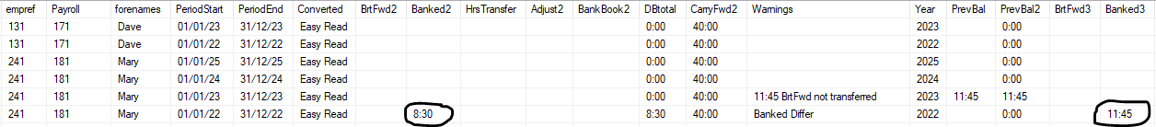

Bonus information is I am instructed not to add or alter the database permanently. In the script you will find a function that creates then drops at the end. This converts seconds into HH:MM and this can handle time over 100:00 and negative time values. I could not find any premade function that was able to work even though their documentation said it could. If you move the @unit varchar(20) = 'ss'; into the calling section you will be able to minutes and hours (need to remove the =’ss’ as I always work in seconds.